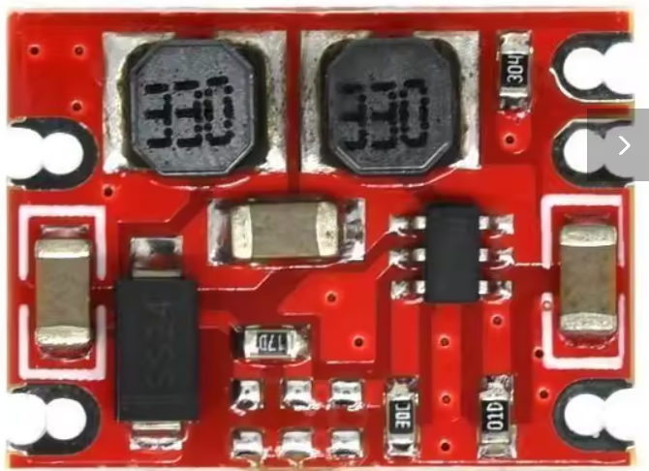

1-10pcs S09 DC-DC Automatic Buck Boost Power Module Step Up Down Board DC DC Input 3-15V Output 3.3V/5V Electronic DIY PCB

Specifications
- High-concerned chemical
None
is_customized
Yes
- Dissipation Power
n/a
Supply Voltage
n/a
- Application
Computer
Type
Module
- Brand Name
SZYTF
Origin
Mainland China
- Condition
New
Operating Temperature
n/a
Description
report
Product Description:
The S09 a wide voltage and low power scheme. The DC-DC power module is automatically raised and lowered to support the shutdown function. The maximum input voltage is 15VDC, the quiescent current is less than 200uA, the fixed output is 3.3V and the maximum output current is 600mA. Design work frequency of up to 1.2MHZ, high stability, cost-effective, all industrial-grade components, long working voltage drift-free, suitable for demanding applications, mass production.

Application:
Widely used in communications equipment, digital radio, industrial motherboards, toys, model aircraft, microcontroller motherboards, household electrical appliances, automotive power supply, security monitoring, field collection, street lamps.

Specifications:
input voltage:2.5V-15V
output voltage:3.3V/4.2V/5V/9V/12V
output current:0.6A
conversion efficiency:75%
output ripple:<50mV
output accuracy:+-0.1V
working temperature:-20 - +85 celsius
relative humidity:20-90%
size:19mm*14mm*4.2mm
pcb layers:2 layers
current control:with cut off
cooling method:cooling nature
installation method:SMD or 2.54mm pin
production process:reflow
isolated:no
design aging standards:720 hours without trouble
production factory aging standards:48 hours
service life:35000 hours without trouble
inspection standards 3 times:all(Ex-factory test + in-store test)
fixed switching frequency:1200khz

Additional regulatory information
For items delivered from outside the European Union, you may be subject to additional charges for VAT and, when applicable, customs duties in your country. If AliExpress is obliged by law to collect VAT, you will see the VAT inclusive price at checkout. For more information about these costs, please contact the tax and customs authorities in your country.
Product compliance information
https://www.aliexpress.com/item/1005006289357253.html?spm=a2g0o.order_list.order_list_main.46.1c5918025L4FkG

